Demographics and Correlations of the Gamer Population

By, Emeka Nwosu

SOC 492-80

Senior Seminar

Douglas McConatha

5/1/2014

**Introduction**

Playing video games has been my biggest passion throughout my life. My earliest memories are playing Super Mario Bros. on the Nintendo with my older brother. This hobby of mine only ramped up as I grew old enough to have my own console, buy my own games, and choose how responsible or irresponsible I want to be with my game time.

With age came maturity and a change in how I look at video games. Sitting down and playing in my own little world was not enough. I became more interested in the development process behind video games, the business side of publication, and most importantly, the simple act of talking to others people about video games. Everyone has their own opinions about which games are good and which ones are bad. I’ve had debates with classmates on the school bus about Gamecube vs. Playstation 2 vs. Xbox. I’ve argued about why The Legend of Zelda: A Link to the Past is better than The Legend of Zelda: Ocarina of Time. I’ve discussed fighting game tactics with a player from New York and a player from Detroit and both players had completely opposite yet effective strategies for overcoming a certain scenario.

Looking back at my history of silly video game arguments made me think about what attracts certain people to certain games. Why do hardcore anime fans usually play a lot of role-playing games? Why do stereotypical “bros” play Madden and Call of Duty? Is this just a coincidence or do certain groups of people approach video games from a different perspective? This research project answers the question “do different people approach video games differently based on their demographics?”

Personal attachment aside, I believe that this research has two legitimate uses. Knowing who plays what types of games is useful for marketing so that advertisements for a game can be aimed at the people who are most likely interested in it. On the development side, games can be created with the types of features their target demographic is interested in.

**Literature Review**

ESA Statistics

The Entertainment Software Association (ESA) annually performs a study similar to my own. They do not go into the details of why certain groups play certain games, but they do discover many in depth descriptive statistics of the gaming population. Their study shows that 58% of Americans play video games with over 50% of households having at least one game console. 32% of the gaming population is younger than 18 years old. 32% is between the ages of 18 and 35. The remaining 36% is 36 or older. Genders are split 55% male and 45% female. The industry has grown I dollar sales over the years. 2002 had a revenue of 6.9 billion dollars and that amount increased to 14.8 billion in 2012.

The Sales, Demographics and Usage Data provided a good idea of what my data should look like. It also shows where the industry is in terms of growth and demographics.

Gamer Demographics Dispel Stereotypes

There is an article on adani.com that goes through a few stereotypes people have about the gaming population and explains how those stereotypes are not true through stats discovered by the ESA and other similar sources. The first few stereotypes dispelled are related to gender. Not only do women make up 45% of the gaming population, but there are actually twice as many women over the age of 18 playing video games than boys under the age of 18. 50% of gamers work full-time and only 11% are unemployed, dispelling the stereotype that gamers sit in their mom’s basement and play games all day.

This article is important because we need stop thinking of gamers as just the cliché nerdy character you see in 90’s pop culture. There is a wide variety of gamers and a wide variety of games. The sooner we accept the fact there more types of games than Grand Theft Auto and Call of Duty and more types of people playing games than the guy living in his mom’s basement with no job, the sooner the industry can move forward. This means games aimed at a different audience can get more time in the spotlight and developers can take more risks with the types of games they create.

How Facebook Inspired *Remember Me* to Drop Global Warming, and why its Protagonist had to be a Woman

There is an article on Penny Arcade about the 2013 action-adventure game, *Remember Me.* The game’s director, Jean-Max Moris, had a difficult time pitching the game to publishers simply because the protagonist is a woman. He got responses such as “Well, we don't want to publish it because that's not going to succeed. You can't have a female character in games. It has to be a male character, simple as that.” Changing the character to a man was not an option either. Moris then says “We wanted to be able to tease on Nilin's [main character] private life, and that means for instance, at one point, we wanted a scene where she was kissing a guy. We had people tell us, 'You can't make a dude like the player kiss another dude in the game, that's going to feel awkward.'”

This way of thinking is holding game development back. “I'm like, 'If you think like that, there's no way the medium's going to mature,'” Moris said. “There's a level of immersion that you need to be at, but it's not like your sexual orientation is being questioned by playing a game. I don't know, that's extremely weird to me.” There are so many different types of people playing video games these days. Different people may look for different features and themes in their games. The best way for the industry to progress is to take a better look at who is playing games and adjust the efforts of game development to appeal to the demographics who are often overlooked.

**Research and Design**

My method of research was purely qualitative. I believe this was the best choice because I decided to focus on trends in different groups of people rather than individuals personal experiences with video games. Interviews could be useful for a personal more detailed explanation on the results if I decide to continue researching this topic.

I created and distributed a simple survey. The questions were separated into two sections. The first section consisted of questions about the subject’s demographics (age, race, gender, etc.). I looked at questions one would find in a census, but avoided questions about subjects a typical college student may not be able to answer accurately like income and questions I didn’t feel were relevant like religion. These served as my independent variables. The second section had my dependent variables about the subject’s interaction with video games. These questions were about the video game habits and preferences I was in such as average hours of play time, number of games purchased, preferred type of game, etc. The general strategy was to use my independent variables about demographics to explain my dependent variables about video games.

The list of questions included

Demographic Questions

1. What is your age?
2. What is your gender?
3. What is your race?
4. What is the highest year of school you have completed?
5. What is your region of residence?

Video game questions

1. On average, how many hours do you spend playing video games each week?
2. Approximately, how many video games have you purchased in the past year?
3. Approximately, how much money have you spend on video games (including game hardware, accessories, DLC, etc.) in the past year?
4. What is your primary gaming platform?
5. What is your favorite video game genre
6. On average, how many days a week do you play video games online?
7. On average, how many days a week do you play video games with other people in person?
8. Have you ever paid money to enter any type of video game competition?

After the data collection was completed, I entered and analyzed the results using the program, SPSS. The first step of analysis was the descriptive statistics. I created very basic pie charts, bar charts, and histograms to display what my sample looked like. The second step was looking at the correlation coefficients between the pairs of variables. I looked for significance among the pairs of variables to see what is worth analyzing in more detail. Initially, there was a third step for multivariate analysis in which I would look at two independent (or “predictor”) variables to explain one dependent (or “output”) variable. This would give more detail explaining the relationship among the pairs of variables, but sample size was not large enough to go through with it.

**Descriptive Analysis**

Age (Figure D1)

The mean age of the sample is 20.48 years ranging from 18 to 27. College students made up the majority of the sample with 61% ranging from ages 18 to 20 years old.

Gender (Figure D2)

The gender distribution of the sample was 62.8% male and 37.2% female. There was also one person who selected “other,” but I had to recode the variable to exclude that person to perform my analysis. The male to female distribution is a not too far off from the data collected by the ESA showing a 55% to 45% male to female distribution considering the limitation in my sampling process.

Race (Figure D3)

An overwhelming majority of the sample is White with very few Hispanic/Latinos and Asians. I had to recode the variable into a dichotomous “White” and “not white” variable to perform any analysis. With that, 60% of the sample is White with the other 40% being Not White.

Education (Figure D4)

The education variable is very closely related to the age variable with a correlation coefficient of .717. This variable was mostly used the same way age was used for analysis. I believe some people misunderstood the question as it was written “What is the highest year of school you have **COMPLETED**” and many people answered with what I already knew to be their current year of school.

Region of Residence (Figure D5)

The region of residence distribution showed 13.6% living in urban environments, 72.7% in suburban, 11.4% rural, and 2.3% chose “other.” Unfortunately, this variable was useless in my analysis. I was left with no choice but to recode the variable into two categories, “suburban” and “not suburban.” The problem with this is grouping urban and rural populations makes no sense when comparing them to the suburban population. My intensions with this variable was looking at the difference in population density of the region in comparison time spent playing games locally and online. However, grouping the most densely populated area and the least densely populated area was not good for regression analysis.

Time Spent Playing games (Figure D6)

The mean time spent playing games is about 12.5 hours per week. There was one major outlier who claimed to play 100 hours per week. I talked to this person and he explained to me that he constantly plays games on his phone during class in addition to standard video game playing time. This made me think about the game time people may not think about like playing a puzzle game on a smartphone during a commercial break on TV or while waiting in line. We may spend more time playing games than we realize.

Number of Games Purchased (Figure D7)

The mean number of games people purchased in the past year is 9.09. What I found interesting is that three people have not purchased any games in the past year yet still spend time playing. There could be some conflict with borrowing games or getting free games via services lie Playstation Plus. Many of the higher game purchasers mentioned sales on the video game distribution service, Steam. It is well known in the gaming community for people to purchase numerous games on Steam during the sales, yet never make the time to play most of them simply because the prices are so good.

Amount of Money Spent on Video Games (Figure D8)

The average amount of money spent on video game hardware and software is $211.64. It is worth noting that the Playstation 4 (MSRP $400) and Xbox One (MSRP $500) released in this past fall. Many of the subjects who spent hundreds of dollars in the past year were purchasers of these consoles.

Primary Video Game Platform (Figure D9)

The primary game platform variable had too many categories for the small sample size. I combined the Playstation, Xbox, and Wii players into “console” and the 3DS, Vita, iOS/Android players into “handheld.” With this, 51.1% of my sample primarily play console games, 31.1% play on PC/Mac, and 17.8% play on handheld devices.

Favorite Type of Video Game (Figure D10)

The variable for favorite game type was a little tricky. I could easily have the same issue I had in primary game platform. Including every type of video game would mean too many choices and not enough people to fill them. The issue with region also occurs here because group random genres together like shooter and puzzle game does not make sense.

My data shows action/adventure and role-playing games being the most popular with 31.1% and 40%. The ESA data shows Action and adventure combining for 30.6% of total sales in 2012 and role-playing games with 6.5% of total sales. I believe the significantly high number of role-playing game fans is due to the fact that I used a convenience sample and about half my data came from the WCU Anime Club which has a lot of cross-over between role-playing game fans.

Time Spent Playing Video Games Online (Figure D11)

I was surprised to see that 48.9% of my sample did not play games online at all. There is such a wide variety of game with online play that some people who aren’t “typical” online gamers actually still play online. This variable was also recoded into two variables “online” and “not online.”

Time Spent Playing Local Multiplayer Video Games (Figure D12)

The local multiplayer variable had a more evenly spread out distribution. 0 days and 2 days a week each had 22.2%. I believe that the two days a week is very popular because most of the respondents are part of video game club. I assume they play locally once during club and again on the weekend.

Competitive Video Game Playing (Figure D13)

35.6% of my sample has paid money to enter a video game competition. I was not sure what to expect from this variable. It could be used in deeper analysis to potentially explain why some people spend more time playing games than others.

Bivariate Analysis

Gender Comparisons (Figure B1 and B2)

I compared the means of the “Time spend playing video games” variable between the two genders, male and female. The difference in means is statistically significant (t score= .05) with males playing an average of 16.22 hours/week and females playing an average of 6.78. It is also worth noting that there is an outlier. One male respondent plays for an average of 100 hours/week. I removed the outlier and to my surprise, I actually got a more statically significant score (t score= .004). This is because despite the difference between the two sample means being smaller, removing the outlier decreased the standard deviation of the male sample by a greater margin making the difference more significant overall.

The comparison of the mean “Money spent on video games in in the past year” between the two genders, male and female, was also statistically significant (t score= .001). The male sample has a mean of $315.46 and the mean for females is $67.81. Only one female spent $200 in the past year while 16 males spent =>$200.

Age comparison (Figure B3)

The Correlation between age and “money spent on video games in the past year” is statistically significant (Pearson Correlation= .518). This correlation was significant mid-way through my data entry. I later added a few more subjects, one of which was the oldest (27 years old) and spent the most money ($1300). Two new consoles, Playstaion 4 and XBOX One, launched last November. Those consoles cost $400-$500. I talked to the subjects who claimed to have spent =>$400 and most of them said they bought one of new consoles in the fall.

Online gaming (Figure B4, B5, an B6)

I recoded the “online multiplayer” and “local multiplayer” variables into dichotomous (Yes/No) variables as opposed to measuring them by number of days a week spent playing for my analysis because of the small sample size. The correlation between the two dichotomous was no surprisingly not significant (Pearson Chi-Square= .936). There was almost a perfect 50% split between online and not online play for both the “local multiplayer” column and the no “local multiplayer” column. I expected people to prefer one form of multiplayer over the other or to replace local multiplayer with online multiplayer, but it turns out that there is no relationship between the two.

Online gaming is known to have a lot of people who discriminate against people of other races, genders, or sexual orientation. Everyone hides behind the veil of a screen name, so one can say hurtful things without any consequence.

I first checked the correlation between a dichotomous race variable of “white” and “not white” and compared it to the dichotomous online multiplayer variable. The relationship is statistically significant (Pearson Chi-Square= .054). The value is actually barely misses the critical value of .05, but the sample size is only 44 so I decided to be lenient about it and call it significant. I followed this up by checking the correlation of the race with the original non-dichotomous online multiplayer variable, but I removed all subjects who did not play games online at all. This way I am able to see which racial group of online players spends more time playing. The mean comparison was not significant (t score= .877). Nonwhite gamers are more likely to play online, but of the people playing online, race has no relationship between time spent playing.

The next comparison I did was between gender and the dichotomous online multiplayer variable. The Correlation between the two is significant (Pearson Chi-Square= .024). 66% of males play online while 45% of females play online. I repeated the process of checking which group of online players spends more time playing, but comparing the 18 male online players to the very small 5 female online players would not produce results with enough statistical power worth analyzing.

**Conclusion**

Age as an indicator

Older gamers are spend more money on video games. This fairly obvious as children limited by the amount of games their parents are willing to buy them. People who are out of school and working have more disposable income to spend on their video game hobby. The highest spenders purchased the new consoles in the fall so launch lineups should gear towards the older audience who will have the money to spend $400-$500 on a new console.

Gender as an Indicator

Males spend more money on video games and spend more time playing than females. The highest spenders all bought the new consoles in the fall so new consoles should focus their launch lineup towards male gamers. Video games that are either very long or have a lot of replay value should also be geared towards the male audience as they are also spending more time with their games.

Online Multiplayer

There is no relationship between gamers who like local multiplayer and gamers who like online multiplayer. A gamer who plays multiplayer games in person is neither more likely nor less likely to play a game online.

Non-white gamers are more likely to play games online so games that heavily feature online play should be advertised heavily in areas where there are minorities. They do not necessarily spend any more time playing online, but they are more likely to do so.

Male gamers are also more likely to play a video game online than female gamers. However this not necessarily be true for fans of role-playing games. Role-playing games were the favorite genre for both genders. 44.4% of males chose role-playing games as their favorite and 31.3% of females did the same. Further analysis could be done to analyze the relationship between gender, online play, and genre, but I would need a larger sample size.

Final Conclusion

My conclusion is that there is difference in the way people play video games based on the demographics they belong to. Some difference as obvious as older age correlating to the amount of money one can spend on video games. Males spending more money and spending more time playing confirms the assumption most people have about gamers in that it’s a boys club. From my experience, it is. The difference in race and online play interests me most for further research. One could come up with a few possible explanations as to why non-whites are more attracted to online play than whites, but an accurate explanation would require an interview.

There are still many questions left unanswered. There are relationships involving variables such as region of residence and favorite game genre that cannot be properly analyzed without a much larger sample.

**Research Shortcomings**

Sample size

The biggest issue with my research was my small sample size. I know plenty of gamers, but I was not able to get data from enough of them in reasonable period of time. The sample size capped at 45 which was not enough to perform most of the in depth analyses I was looking for. I circumvented this issue in the best way I could by recoding some of the variables in SPSS. For example, I did not receive a sufficient number of subjects in specific minorities so the “Race” variable was recoded into “white” and “not white” for my analysis.

Convenience sample

In addition to the small sample size, I was also left with no choice but to use convenience sampling. The good thing is that I knew all of my subjects were gamers and who would provide relevant information for my research, but there were a too many similarities. The first group I collected data from was the West Chester University Anime Club. These are all people who share an interest in watching anime and anime watchers tend to enjoy Japanese role-playing games. 40% of the sample chose role-playing games as their favorite genre which doesn’t match up to the ESA data which shows that role-playing games only sold 6.5% during the year 2012.

Access to better data

I knew there would be some issues with the data from the survey questions about the subject’s money spent on video games and number of games bought. When handing out the survey, I heard many people say something along the lines of “oh man I can’t remember how many games I’ve bought.” I used the word “approximately” to make things easier on them knowing that most people don’t keep well enough track of that. I could get accurate data if I had access to purchases from an online outlet like Xbox Live, Playstation Network, or Steam. My population size would have to shrink to gamers who specifically use one of those services, but the data would be more accurate.

**Plans for Future Research**

Wider Range of Ages

I originally wanted to collect data from middle school students and high school students to compare to the college students I collected from in my sample. Collecting data from children is very difficult, but I have a close enough connection to my middle school and high school that I could have potentially made it work. I was not able to do so due to because of traveling issues.

In the future, I would like to expand the age range of my sample to compare the ways in which people play video games based on their stage in life. I and many other people talk about how willing we were as children to put up with bad games, or grind through one really long game when we were younger and had fewer options. I believe this could provide some interesting analysis which could help developers design games better for specific age groups.

Interviews

My entire data is based off quantitative data. My original idea was to use the data to justify an interview. For example, if there was a trend in a certain group of people playing games in a specific way, I would interview someone from within that group to get a detailed explanation as to why that is. The interview would provide a more accurate and personal analysis than my interpretation based on people I have interacted with.

Different gamer groups

The gaming population can my segregated into a number of different communities. There is the fighting game scene, e-sports, speed runners, modders, etc. Everyone in these groups is playing different types of games for different reasons. Games like *Shadow Complex* and *Metroid* take many hours to beat the first time through, but can be completed very quickly once a players knows the ins and outs. Looking at gamers by their specific group could answer questions about why one group is made up of certain types of people compared to another group.

**Annotated Bibliography**

"Essential Facts about the Computer and Video Game INdustry." The Entertainment Software Association, n.d. Web. 28 Feb. 2014.

"Expanded Information on Voices of Women in Smash." Melee It On Me. N.p., n.d. Web. 01 May 2014.

"Game Development 1001." N.p., n.d. Web. 28 Feb. 2014.

"Gamer Demographics Dispel Stereotypes | Gaming | ADANAI." ADANAI. Tyler F.M. Edwards, 4 June 2013. Web. 01 May 2014.

"Growing up in the Super Smash Brothers Melee Community as a Girl." Ramblings of a Retired Gamer —. _milktea, 17 Oct. 2013. Web. 01 May 2014.

"How to Tackle Gaming's Lack of Racial Diversity." Polygon. Colin Campbell, 16 Sept. 2013. Web. 01 May 2014.

"MIT Press Journals - Presence: Teleoperators and Virtual Environments - Abstract." MIT Press Journals - Presence: Teleoperators and Virtual Environments - Abstract. N.p., n.d. Web. 01 May 2014.

"State of Online Gaming Report." Spill Games, n.d. Web. 28 Feb. 2014.

"Virtual Worlds: The Rise of E-Sports." Online Game Design Degrees and Schools. N.p., n.d. Web. 01 May 2014.

"Voices of Women in Smash – Competitive Super Smash Bros. Player Lilo Shines a Light on Sexism in the Community." Shoryuken. Julius Vissing, 10 Mar. 2014. Web. 01 May 2014.

"Why the Fighting Game Community Is Color Blind." Polygon. Mitch Bowman, 6 Feb. 2014. Web. 01 May 2014.

"Worldwide Video Game, Internet and Smartphone Usage Statistics." Margaret Wallace. N.p., n.d. Web. 01 May 2014.

**Descriptive Analysis Output**

**Age of Sample (Figure D1)**

|  |  |  |
| --- | --- | --- |
| **Statistics** | | |
| Age of person (years) | | |
| N | Valid | 44 |
| Missing | 1 |
| Mean | | 20.48 |
| Range | | 9 |
| Minimum | | 18 |
| Maximum | | 27 |

|  |  |  |  |  |  |
| --- | --- | --- | --- | --- | --- |
| **Age of person (years)** | | | | | |
|  | | Frequency | Percent | Valid Percent | Cumulative Percent |
| Valid | 18 | 6 | 13.3 | 13.6 | 13.6 |
| 19 | 12 | 26.7 | 27.3 | 40.9 |
| 20 | 9 | 20.0 | 20.5 | 61.4 |
| 21 | 5 | 11.1 | 11.4 | 72.7 |
| 22 | 4 | 8.9 | 9.1 | 81.8 |
| 23 | 5 | 11.1 | 11.4 | 93.2 |
| 24 | 1 | 2.2 | 2.3 | 95.5 |
| 26 | 1 | 2.2 | 2.3 | 97.7 |
| 27 | 1 | 2.2 | 2.3 | 100.0 |
| Total | 44 | 97.8 | 100.0 |  |
| Missing | No response | 1 | 2.2 |  |  |
| Total | | 45 | 100.0 |  |  |

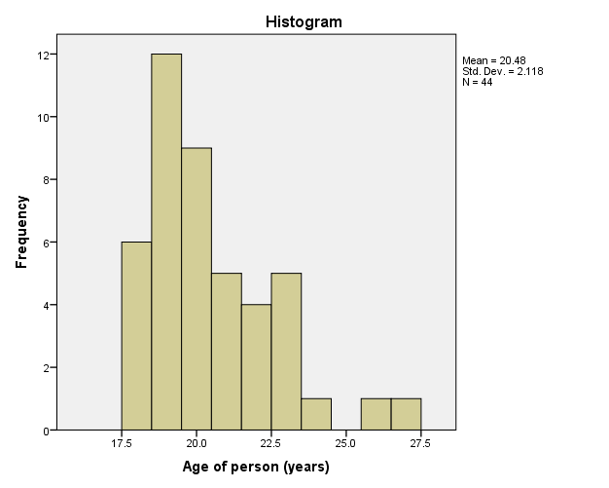

**Gender of Sample (Figure D2)**

|  |  |  |
| --- | --- | --- |
| **Statistics** | | |
| Gender of person | | |
| N | Valid | 44 |
| Missing | 1 |

|  |  |  |  |  |  |
| --- | --- | --- | --- | --- | --- |
| **Gender of person** | | | | | |
|  | | Frequency | Percent | Valid Percent | Cumulative Percent |
| Valid | Male | 27 | 60.0 | 61.4 | 61.4 |
| Female | 16 | 35.6 | 36.4 | 97.7 |
| Other | 1 | 2.2 | 2.3 | 100.0 |
| Total | 44 | 97.8 | 100.0 |  |
| Missing | No response | 1 | 2.2 |  |  |
| Total | | 45 | 100.0 |  |  |

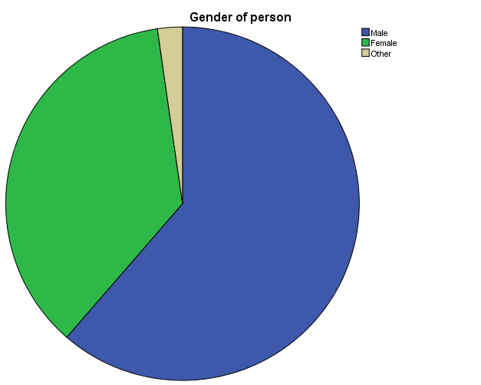

**Race of Sample (Figure D3)**

|  |  |  |
| --- | --- | --- |
| **Statistics** | | |
| Race of person | | |
| N | Valid | 44 |
| Missing | 1 |

|  |  |  |  |  |  |
| --- | --- | --- | --- | --- | --- |
| **Race of person** | | | | | |
|  | | Frequency | Percent | Valid Percent | Cumulative Percent |
| Valid | Asian | 1 | 2.2 | 2.3 | 2.3 |
| Black/African American | 8 | 17.8 | 18.2 | 20.5 |
| Hispanic/Latino | 2 | 4.4 | 4.5 | 25.0 |
| White | 27 | 60.0 | 61.4 | 86.4 |
| Two or more races | 6 | 13.3 | 13.6 | 100.0 |
| Total | 44 | 97.8 | 100.0 |  |
| Missing | No response | 1 | 2.2 |  |  |
| Total | | 45 | 100.0 |  |  |

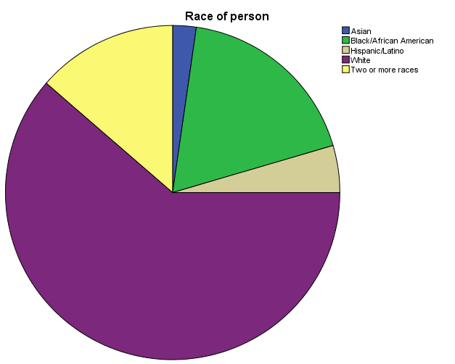

**Education Level of Sample (Figure D4)**

|  |  |  |
| --- | --- | --- |
| **Statistics** | | |
| Highest year of school completed | | |
| N | Valid | 43 |
| Missing | 2 |

|  |  |  |  |  |  |
| --- | --- | --- | --- | --- | --- |
| **Highest year of school completed** | | | | | |
|  | | Frequency | Percent | Valid Percent | Cumulative Percent |
| Valid | 12 | 15 | 33.3 | 34.9 | 34.9 |
| 13 | 7 | 15.6 | 16.3 | 51.2 |
| 14 | 5 | 11.1 | 11.6 | 62.8 |
| 15 | 7 | 15.6 | 16.3 | 79.1 |
| 16 | 7 | 15.6 | 16.3 | 95.3 |
| 17 | 1 | 2.2 | 2.3 | 97.7 |
| 18 | 1 | 2.2 | 2.3 | 100.0 |
| Total | 43 | 95.6 | 100.0 |  |
| Missing | No answer | 2 | 4.4 |  |  |
| Total | | 45 | 100.0 |  |  |

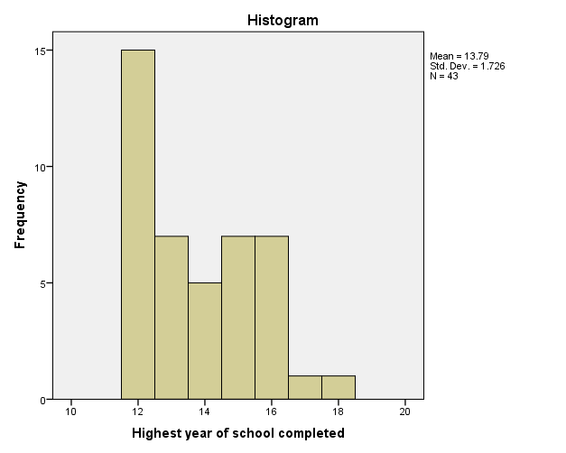

**Region of Residence of Sample (Figure D5)**

|  |  |  |
| --- | --- | --- |
| **Statistics** | | |
| Region of residence | | |
| N | Valid | 44 |
| Missing | 1 |

|  |  |  |  |  |  |
| --- | --- | --- | --- | --- | --- |
| **Region of residence** | | | | | |
|  | | Frequency | Percent | Valid Percent | Cumulative Percent |
| Valid | Urban | 6 | 13.3 | 13.6 | 13.6 |
| Suburban | 32 | 71.1 | 72.7 | 86.4 |
| Rural | 5 | 11.1 | 11.4 | 97.7 |
| Other | 1 | 2.2 | 2.3 | 100.0 |
| Total | 44 | 97.8 | 100.0 |  |
| Missing | No response | 1 | 2.2 |  |  |
| Total | | 45 | 100.0 |  |  |

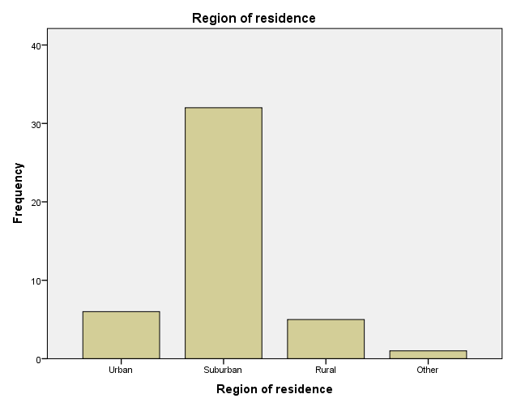

**Video Game Play Time of Sample (Figure D6)**

|  |  |  |
| --- | --- | --- |
| **Statistics** | | |
| Average time spent playing video games (hours/week) | | |
| N | Valid | 44 |
| Missing | 1 |
| Mean | | 12.4886 |
| Minimum | | 2.00 |
| Maximum | | 100.00 |

|  |  |  |  |  |  |
| --- | --- | --- | --- | --- | --- |
| **Average time spent playing video games (hours/week)** | | | | | |
|  | | Frequency | Percent | Valid Percent | Cumulative Percent |
| Valid | 2.00 | 4 | 8.9 | 9.1 | 9.1 |
| 3.00 | 4 | 8.9 | 9.1 | 18.2 |
| 4.50 | 1 | 2.2 | 2.3 | 20.5 |
| 5.00 | 4 | 8.9 | 9.1 | 29.5 |
| 6.00 | 2 | 4.4 | 4.5 | 34.1 |
| 7.00 | 2 | 4.4 | 4.5 | 38.6 |
| 8.00 | 2 | 4.4 | 4.5 | 43.2 |
| 9.00 | 2 | 4.4 | 4.5 | 47.7 |
| 10.00 | 7 | 15.6 | 15.9 | 63.6 |
| 12.00 | 2 | 4.4 | 4.5 | 68.2 |
| 14.00 | 3 | 6.7 | 6.8 | 75.0 |
| 15.00 | 2 | 4.4 | 4.5 | 79.5 |
| 16.00 | 1 | 2.2 | 2.3 | 81.8 |
| 20.00 | 3 | 6.7 | 6.8 | 88.6 |
| 21.00 | 1 | 2.2 | 2.3 | 90.9 |
| 24.00 | 1 | 2.2 | 2.3 | 93.2 |
| 28.00 | 1 | 2.2 | 2.3 | 95.5 |
| 30.00 | 1 | 2.2 | 2.3 | 97.7 |
| 100.00 | 1 | 2.2 | 2.3 | 100.0 |
| Total | 44 | 97.8 | 100.0 |  |
| Missing | No response | 1 | 2.2 |  |  |
| Total | | 45 | 100.0 |  |  |

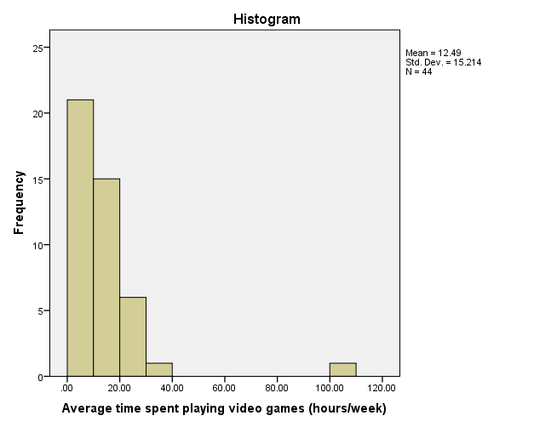

**Number of Games Purchased of Sample (Figure D7)**

|  |  |  |
| --- | --- | --- |
| **Statistics** | | |
| Number of games purchased in past year | | |
| N | Valid | 43 |
| Missing | 2 |
| Mean | | 9.09 |
| Minimum | | 0 |
| Maximum | | 70 |

|  |  |  |  |  |  |
| --- | --- | --- | --- | --- | --- |
| **Number of games purchased in past year** | | | | | |
|  | | Frequency | Percent | Valid Percent | Cumulative Percent |
| Valid | 0 | 3 | 6.7 | 7.0 | 7.0 |
| 1 | 3 | 6.7 | 7.0 | 14.0 |
| 2 | 3 | 6.7 | 7.0 | 20.9 |
| 3 | 3 | 6.7 | 7.0 | 27.9 |
| 4 | 3 | 6.7 | 7.0 | 34.9 |
| 5 | 9 | 20.0 | 20.9 | 55.8 |
| 6 | 2 | 4.4 | 4.7 | 60.5 |
| 7 | 1 | 2.2 | 2.3 | 62.8 |
| 8 | 1 | 2.2 | 2.3 | 65.1 |
| 10 | 6 | 13.3 | 14.0 | 79.1 |
| 11 | 1 | 2.2 | 2.3 | 81.4 |
| 12 | 1 | 2.2 | 2.3 | 83.7 |
| 15 | 2 | 4.4 | 4.7 | 88.4 |
| 16 | 1 | 2.2 | 2.3 | 90.7 |
| 20 | 2 | 4.4 | 4.7 | 95.3 |
| 50 | 1 | 2.2 | 2.3 | 97.7 |
| 70 | 1 | 2.2 | 2.3 | 100.0 |
| Total | 43 | 95.6 | 100.0 |  |
| Missing | No response | 2 | 4.4 |  |  |
| Total | | 45 | 100.0 |  |  |

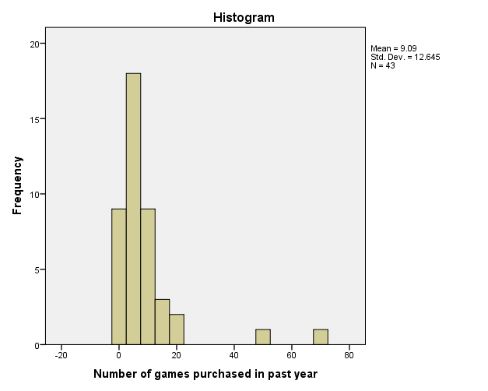

**Money Spent of Sample (Figure D8)**

|  |  |  |
| --- | --- | --- |
| **Statistics** | | |
| How much money spent on video games in past year | | |
| N | Valid | 44 |
| Missing | 1 |
| Mean | | 211.64 |
| Minimum | | 0 |
| Maximum | | 1300 |

|  |  |  |  |  |  |
| --- | --- | --- | --- | --- | --- |
| **How much money spent on video games in past year** | | | | | |
|  | | Frequency | Percent | Valid Percent | Cumulative Percent |
| Valid | 0 | 4 | 8.9 | 9.1 | 9.1 |
| 10 | 1 | 2.2 | 2.3 | 11.4 |
| 20 | 1 | 2.2 | 2.3 | 13.6 |
| 25 | 1 | 2.2 | 2.3 | 15.9 |
| 30 | 1 | 2.2 | 2.3 | 18.2 |
| 35 | 1 | 2.2 | 2.3 | 20.5 |
| 40 | 3 | 6.7 | 6.8 | 27.3 |
| 50 | 4 | 8.9 | 9.1 | 36.4 |
| 70 | 1 | 2.2 | 2.3 | 38.6 |
| 80 | 2 | 4.4 | 4.5 | 43.2 |
| 100 | 6 | 13.3 | 13.6 | 56.8 |
| 117 | 1 | 2.2 | 2.3 | 59.1 |
| 150 | 2 | 4.4 | 4.5 | 63.6 |
| 200 | 3 | 6.7 | 6.8 | 70.5 |
| 300 | 3 | 6.7 | 6.8 | 77.3 |
| 325 | 1 | 2.2 | 2.3 | 79.5 |
| 400 | 2 | 4.4 | 4.5 | 84.1 |
| 450 | 1 | 2.2 | 2.3 | 86.4 |
| 500 | 1 | 2.2 | 2.3 | 88.6 |
| 600 | 2 | 4.4 | 4.5 | 93.2 |
| 700 | 1 | 2.2 | 2.3 | 95.5 |
| 850 | 1 | 2.2 | 2.3 | 97.7 |
| 1300 | 1 | 2.2 | 2.3 | 100.0 |
| Total | 44 | 97.8 | 100.0 |  |
| Missing | no response | 1 | 2.2 |  |  |
| Total | | 45 | 100.0 |  |  |

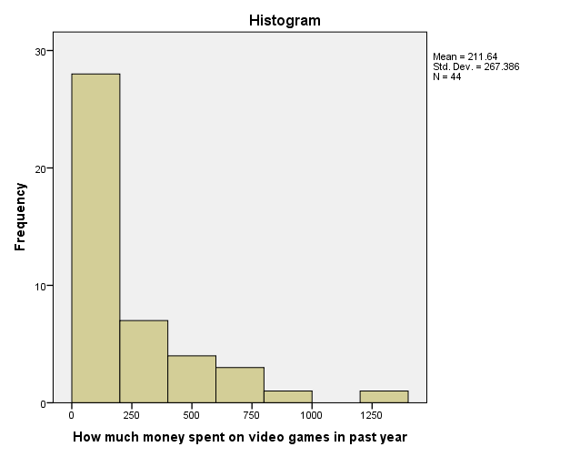

**Primary Game Platform of Sample (Figure D9)**

|  |  |  |
| --- | --- | --- |
| **Statistics** | | |
| Primary gaming platform | | |
| N | Valid | 45 |
| Missing | 0 |

|  |  |  |  |  |  |
| --- | --- | --- | --- | --- | --- |
| **Primary gaming platform** | | | | | |
|  | | Frequency | Percent | Valid Percent | Cumulative Percent |
| Valid | Playstation 3/Playstation 4 | 10 | 22.2 | 22.2 | 22.2 |
| Xbox 360/Xbox One | 8 | 17.8 | 17.8 | 40.0 |
| Wii/Wii U | 5 | 11.1 | 11.1 | 51.1 |
| PC/Mac | 14 | 31.1 | 31.1 | 82.2 |
| DS/3DS | 5 | 11.1 | 11.1 | 93.3 |
| PSP/PS Vita | 1 | 2.2 | 2.2 | 95.6 |
| iPhone/iPad/Android | 1 | 2.2 | 2.2 | 97.8 |
| Other | 1 | 2.2 | 2.2 | 100.0 |
| Total | 45 | 100.0 | 100.0 |  |

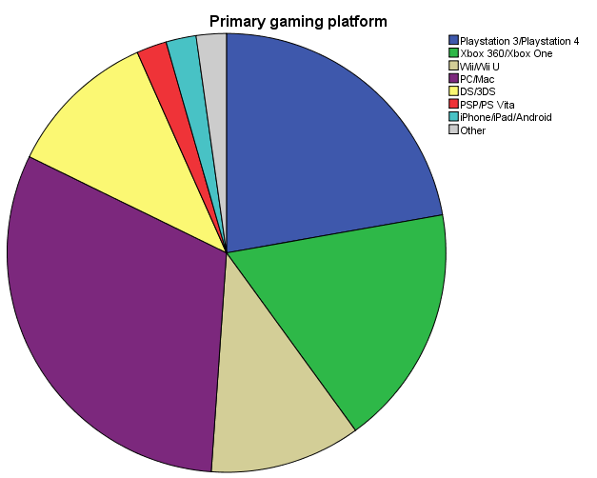

**Favorite Game Type of Sample (Figure D10)**

|  |  |  |
| --- | --- | --- |
| **Statistics** | | |
| What is favorite type of game | | |
| N | Valid | 45 |
| Missing | 0 |

|  |  |  |  |  |  |
| --- | --- | --- | --- | --- | --- |
| **What is favorite type of game** | | | | | |
|  | | Frequency | Percent | Valid Percent | Cumulative Percent |
| Valid | Action/Adventure | 14 | 31.1 | 31.1 | 31.1 |
| FIghting | 2 | 4.4 | 4.4 | 35.6 |
| Music | 1 | 2.2 | 2.2 | 37.8 |
| Platformer | 1 | 2.2 | 2.2 | 40.0 |
| Puzzle | 1 | 2.2 | 2.2 | 42.2 |
| Role Playing Game | 18 | 40.0 | 40.0 | 82.2 |
| Shooter | 3 | 6.7 | 6.7 | 88.9 |
| Other | 5 | 11.1 | 11.1 | 100.0 |
| Total | 45 | 100.0 | 100.0 |  |

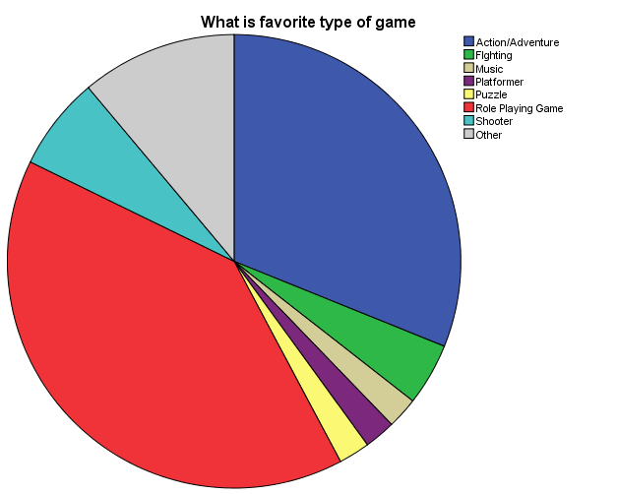

**Online Multiplayer Game Time of Sample (Figure D11)**

|  |  |  |
| --- | --- | --- |
| **Statistics** | | |
| Days a week playing online games | | |
| N | Valid | 45 |
| Missing | 0 |

|  |  |  |  |  |  |
| --- | --- | --- | --- | --- | --- |
| **Days a week playing online games** | | | | | |
|  | | Frequency | Percent | Valid Percent | Cumulative Percent |
| Valid | 0 | 22 | 48.9 | 48.9 | 48.9 |
| 1 | 2 | 4.4 | 4.4 | 53.3 |
| 2 | 2 | 4.4 | 4.4 | 57.8 |
| 3 | 4 | 8.9 | 8.9 | 66.7 |
| 4 | 5 | 11.1 | 11.1 | 77.8 |
| 5 | 3 | 6.7 | 6.7 | 84.4 |
| 7 | 7 | 15.6 | 15.6 | 100.0 |
| Total | 45 | 100.0 | 100.0 |  |

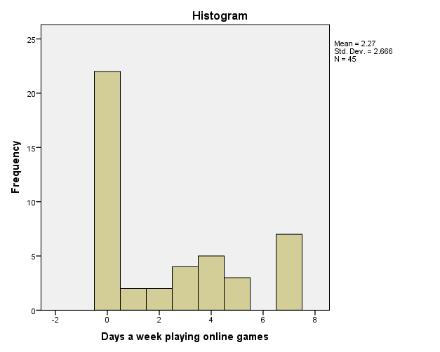

**Local Multiplayer Game Time of Sample (Figure D12)**

|  |  |  |
| --- | --- | --- |
| **Statistics** | | |
| Days a week playing local multiplayer games | | |
| N | Valid | 45 |
| Missing | 0 |

|  |  |  |  |  |  |
| --- | --- | --- | --- | --- | --- |
| **Days a week playing local multiplayer games** | | | | | |
|  | | Frequency | Percent | Valid Percent | Cumulative Percent |
| Valid | 0 | 10 | 22.2 | 22.2 | 22.2 |
| 1 | 7 | 15.6 | 15.6 | 37.8 |
| 2 | 10 | 22.2 | 22.2 | 60.0 |
| 3 | 8 | 17.8 | 17.8 | 77.8 |
| 4 | 5 | 11.1 | 11.1 | 88.9 |
| 5 | 2 | 4.4 | 4.4 | 93.3 |
| 7 | 3 | 6.7 | 6.7 | 100.0 |
| Total | 45 | 100.0 | 100.0 |  |

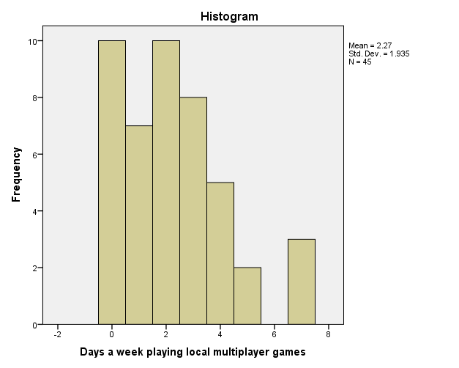

**Number Competitive Gamers of Sample (Figure D13)**

|  |  |  |
| --- | --- | --- |
| **Statistics** | | |
| Have you paid money to enter a video game competition | | |
| N | Valid | 45 |
| Missing | 0 |

|  |  |  |  |  |  |
| --- | --- | --- | --- | --- | --- |
| **Have you paid money to enter a video game competition** | | | | | |
|  | | Frequency | Percent | Valid Percent | Cumulative Percent |
| Valid | No | 29 | 64.4 | 64.4 | 64.4 |
| Yes | 16 | 35.6 | 35.6 | 100.0 |
| Total | 45 | 100.0 | 100.0 |  |

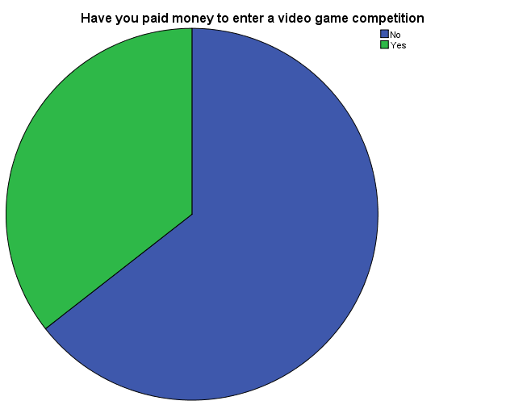

**Bivariate Analysis Output**

**Gender * Time Playing T-Test (Figure B1)**

|  |  |  |  |  |  |
| --- | --- | --- | --- | --- | --- |
| **Group Statistics** | | | | | |
|  | Gender of person | N | Mean | Std. Deviation | Std. Error Mean |
| Average time spent playing video games (hours/week) | Male | 27 | 16.22 | 18.245 | 3.511 |
| Female | 16 | 6.78 | 4.550 | 1.137 |

|  |  |  |  |  |
| --- | --- | --- | --- | --- |
| **Independent Samples Test** | | | | |
|  | | Levene's Test for Equality of Variances | | t-test for Equality of Means |
| F | Sig. | t |
|
| Average time spent playing video games (hours/week) | Equal variances assumed | 2.493 | .122 | 2.024 |
| Equal variances not assumed |  |  | 2.558 |

|  |  |  |  |  |
| --- | --- | --- | --- | --- |
| **Independent Samples Test** | | | | |
|  | | t-test for Equality of Means | | |
| df | Sig. (2-tailed) | Mean Difference |
|
| Average time spent playing video games (hours/week) | Equal variances assumed | 41 | .050 | 9.441 |
| Equal variances not assumed | 31.148 | .016 | 9.441 |

|  |  |  |  |  |
| --- | --- | --- | --- | --- |
| **Independent Samples Test** | | | | |
|  | | t-test for Equality of Means | | |
| Std. Error Difference | 95% Confidence Interval of the Difference | |
| Lower | Upper |
| Average time spent playing video games (hours/week) | Equal variances assumed | 4.665 | .019 | 18.863 |
| Equal variances not assumed | 3.691 | 1.915 | 16.967 |

**Gender * Money Spent T-Test (Figure B2)**

|  |  |  |  |  |  |
| --- | --- | --- | --- | --- | --- |
| **Group Statistics** | | | | | |
|  | Gender of person | N | Mean | Std. Deviation | Std. Error Mean |
| How much money spent on video games in past year | Male | 26 | 315.46 | 302.681 | 59.361 |
| Female | 16 | 67.81 | 78.761 | 19.690 |

|  |  |  |  |  |
| --- | --- | --- | --- | --- |
| **Independent Samples Test** | | | | |
|  | | Levene's Test for Equality of Variances | | t-test for Equality of Means |
| F | Sig. | t |
|
| How much money spent on video games in past year | Equal variances assumed | 12.647 | .001 | 3.193 |
| Equal variances not assumed |  |  | 3.960 |

|  |  |  |  |  |
| --- | --- | --- | --- | --- |
| **Independent Samples Test** | | | | |
|  | | t-test for Equality of Means | | |
| df | Sig. (2-tailed) | Mean Difference |
|
| How much money spent on video games in past year | Equal variances assumed | 40 | .003 | 247.649 |
| Equal variances not assumed | 30.195 | .000 | 247.649 |

|  |  |  |  |  |
| --- | --- | --- | --- | --- |
| **Independent Samples Test** | | | | |
|  | | t-test for Equality of Means | | |
| Std. Error Difference | 95% Confidence Interval of the Difference | |
| Lower | Upper |
| How much money spent on video games in past year | Equal variances assumed | 77.562 | 90.890 | 404.408 |
| Equal variances not assumed | 62.541 | 119.958 | 375.341 |

**Age * Money Spent Correlation (Figure B3)**

|  |  |  |  |
| --- | --- | --- | --- |
| **Descriptive Statistics** | | | |
|  | Mean | Std. Deviation | N |
| Age of person (years) | 20.48 | 2.118 | 44 |
| How much money spent on video games in past year | 211.64 | 267.386 | 44 |

|  |  |  |  |
| --- | --- | --- | --- |
| **Correlations** | | | |
|  | | Age of person (years) | How much money spent on video games in past year |
| Age of person (years) | Pearson Correlation | 1 | .518** |
| Sig. (2-tailed) |  | .000 |
| N | 44 | 43 |
| How much money spent on video games in past year | Pearson Correlation | .518** | 1 |
| Sig. (2-tailed) | .000 |  |
| N | 43 | 44 |

|  |
| --- |
| **. Correlation is significant at the 0.01 level (2-tailed). |

**Local Multiplayer * Online Multiplayer Crosstabs (Figure B4)**

|  |  |  |  |  |  |  |
| --- | --- | --- | --- | --- | --- | --- |
| **Case Processing Summary** | | | | | | |
|  | Cases | | | | | |
| Valid | | Missing | | Total | |
| N | Percent | N | Percent | N | Percent |
| Online/not online player * Local multiplayer or not | 45 | 100.0% | 0 | 0.0% | 45 | 100.0% |

|  |  |  |  |  |  |
| --- | --- | --- | --- | --- | --- |
| **Online/not online player * Local multiplayer or not Crosstabulation** | | | | | |
|  | | | Local multiplayer or not | | Total |
| no local multiplayer | local mulitplayer |
| Online/not online player | No | Count | 5 | 17 | 22 |
| % within Local multiplayer or not | 50.0% | 48.6% | 48.9% |
| Yes | Count | 5 | 18 | 23 |
| % within Local multiplayer or not | 50.0% | 51.4% | 51.1% |
| Total | | Count | 10 | 35 | 45 |
| % within Local multiplayer or not | 100.0% | 100.0% | 100.0% |

|  |  |  |  |  |  |
| --- | --- | --- | --- | --- | --- |
| **Chi-Square Tests** | | | | | |
|  | Value | df | Asymp. Sig. (2-sided) | Exact Sig. (2-sided) | Exact Sig. (1-sided) |
| Pearson Chi-Square | .006a | 1 | .936 |  |  |
| Continuity Correctionb | .000 | 1 | 1.000 |  |  |
| Likelihood Ratio | .006 | 1 | .936 |  |  |
| Fisher's Exact Test |  |  |  | 1.000 | .609 |
| Linear-by-Linear Association | .006 | 1 | .937 |  |  |
| N of Valid Cases | 45 |  |  |  |  |

|  |
| --- |
| a. 1 cells (25.0%) have expected count less than 5. The minimum expected count is 4.89. |
| b. Computed only for a 2x2 table |

**Race * Online Multiplayer Crosstabs (Figure B5)**

|  |  |  |  |  |  |  |
| --- | --- | --- | --- | --- | --- | --- |
| **Case Processing Summary** | | | | | | |
|  | Cases | | | | | |
| Valid | | Missing | | Total | |
| N | Percent | N | Percent | N | Percent |
| Online/not online player * Race (white/ not white) | 44 | 97.8% | 1 | 2.2% | 45 | 100.0% |

|  |  |  |  |  |  |
| --- | --- | --- | --- | --- | --- |
| **Online/not online player * Race (white/ not white) Crosstabulation** | | | | | |
|  | | | Race (white/ not white) | | Total |
| White | Not White |
| Online/not online player | No | Count | 16 | 5 | 21 |
| % within Race (white/ not white) | 59.3% | 29.4% | 47.7% |
| Yes | Count | 11 | 12 | 23 |
| % within Race (white/ not white) | 40.7% | 70.6% | 52.3% |
| Total | | Count | 27 | 17 | 44 |
| % within Race (white/ not white) | 100.0% | 100.0% | 100.0% |

|  |  |  |  |  |  |
| --- | --- | --- | --- | --- | --- |
| **Chi-Square Tests** | | | | | |
|  | Value | df | Asymp. Sig. (2-sided) | Exact Sig. (2-sided) | Exact Sig. (1-sided) |
| Pearson Chi-Square | 3.725a | 1 | .054 |  |  |
| Continuity Correctionb | 2.625 | 1 | .105 |  |  |
| Likelihood Ratio | 3.810 | 1 | .051 |  |  |
| Fisher's Exact Test |  |  |  | .069 | .052 |
| Linear-by-Linear Association | 3.640 | 1 | .056 |  |  |
| N of Valid Cases | 44 |  |  |  |  |

|  |
| --- |
| a. 0 cells (.0%) have expected count less than 5. The minimum expected count is 8.11. |
| b. Computed only for a 2x2 table |

**Gender * Online Multiplayer Crosstabs (Figure B6)**

|  |  |  |  |  |  |  |
| --- | --- | --- | --- | --- | --- | --- |
| **Case Processing Summary** | | | | | | |
|  | Cases | | | | | |
| Valid | | Missing | | Total | |
| N | Percent | N | Percent | N | Percent |
| Online/not online player * Gender of person | 43 | 95.6% | 2 | 4.4% | 45 | 100.0% |

|  |  |  |  |  |  |
| --- | --- | --- | --- | --- | --- |
| **Online/not online player * Gender of person Crosstabulation** | | | | | |
|  | | | Gender of person | | Total |
| Male | Female |
| Online/not online player | No | Count | 9 | 11 | 20 |
| % within Gender of person | 33.3% | 68.8% | 46.5% |
| Yes | Count | 18 | 5 | 23 |
| % within Gender of person | 66.7% | 31.3% | 53.5% |
| Total | | Count | 27 | 16 | 43 |
| % within Gender of person | 100.0% | 100.0% | 100.0% |

|  |  |  |  |  |  |
| --- | --- | --- | --- | --- | --- |
| **Chi-Square Tests** | | | | | |
|  | Value | df | Asymp. Sig. (2-sided) | Exact Sig. (2-sided) | Exact Sig. (1-sided) |
| Pearson Chi-Square | 5.065a | 1 | .024 |  |  |
| Continuity Correctionb | 3.742 | 1 | .053 |  |  |
| Likelihood Ratio | 5.155 | 1 | .023 |  |  |
| Fisher's Exact Test |  |  |  | .032 | .026 |
| Linear-by-Linear Association | 4.948 | 1 | .026 |  |  |
| N of Valid Cases | 43 |  |  |  |  |

|  |
| --- |
| a. 0 cells (.0%) have expected count less than 5. The minimum expected count is 7.44. |
| b. Computed only for a 2x2 table |

**Video Game Survey**

What is your age?

_____ Years

What is your gender?

Male__

Female__

Transgender__

Other__

What is your race?

American Indian/Alaskan Native__

Asian__

Black/African American__

Hispanic/Latino__

Native Hawaiian/Pacific Islander__

White__

Two or more races__

What is the highest year of school you have COMPLETED?

_____

What is your region of residence (home not school)?

Urban__

Suburban__

Rural__

Other__

On average, how many hours do you spend playing video games each week?

____ hours/week

Approximately, how many video games have you purchased in the past year?

____ games

Approximately, how much money have you spent on video games (including game, hardware, peripherals, DLC etc.) in the past year?

$____

What is your primary gaming platform?

Playstation 3/Playstation 4__

Xbox 360/Xbox One__

Wii/Wii U__

PC/Mac__

DS/3DS__

PSP/PS Vita__

iPhone/iPad/Android__

Other__

What is your favorite video genre

Action/Adventure__

Fighting__

Music__

Platformer__

Puzzle__

Role Playing Game__

Racing__

Shooter__

Sports__

Other__

On average, how many days a week do you play a video game online?

____ days/week

On average, how many days a week do you play video games with other people in person?

____ days/week

Have you ever paid money to enter any type of video game competition?

Yes__ No__